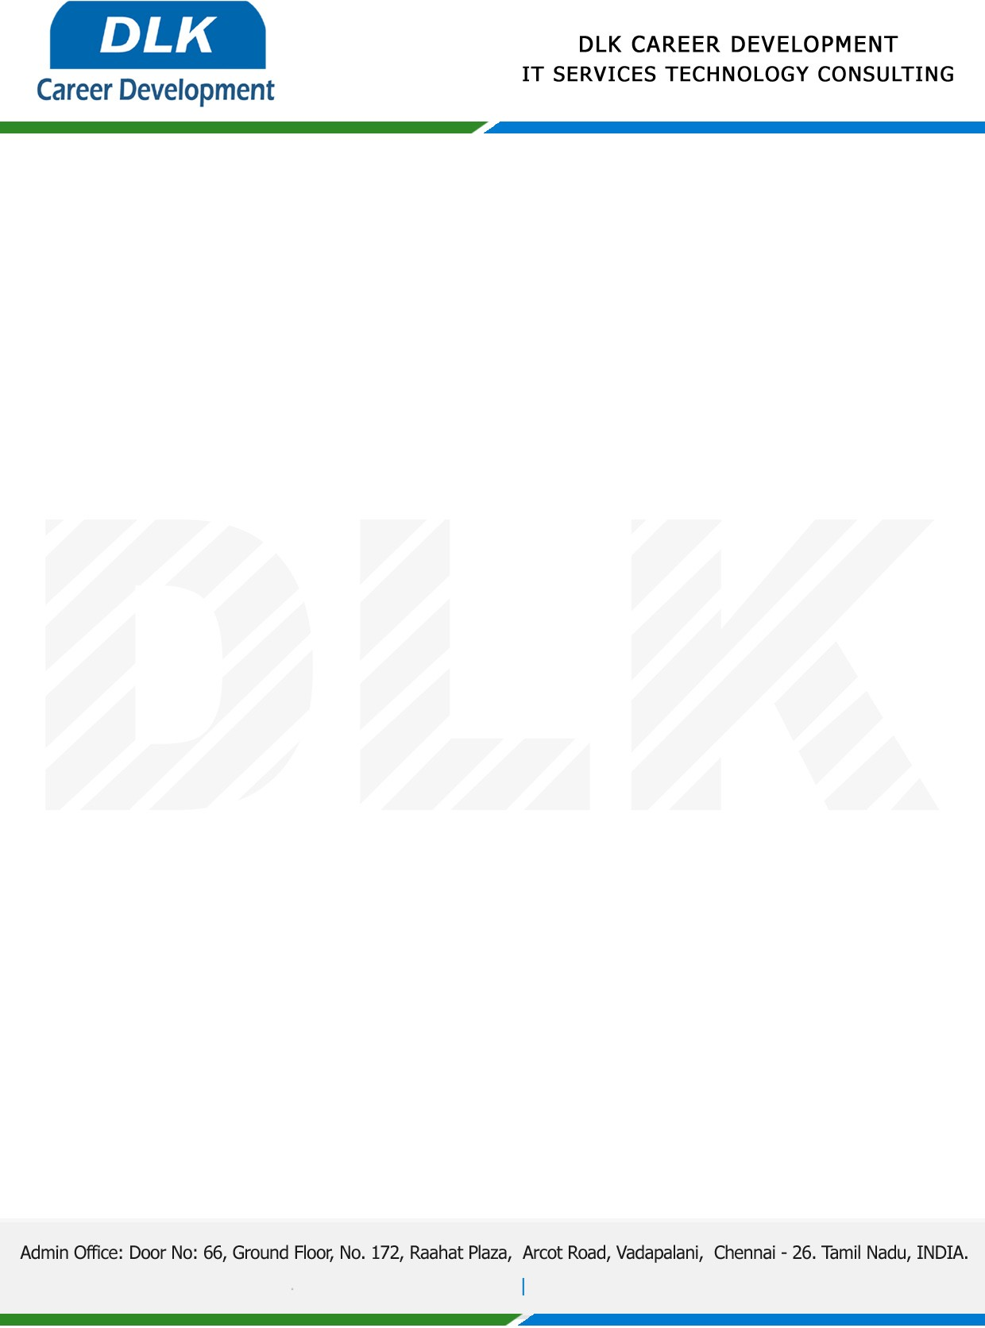

**Date: 17/April /2023**

**SUB: PROJECT COMPLETION CERTIFICATE**

This is to certify that **MS MONIKA M (REG NO:** **212002640) MSC- Computer Science,** final year student **Dr. MGR Janaki College of Arts and Science, Chennai** has Successfully Completed the Project Work under the domain of “**Java”** in our organization during the Period **( 06th March 2023 to 11th March 2023).**

**Topic:** Online Medical Consultation System.

We appreciate your interest in **DLK CAREER DEVELOPMENT**

**“Best Wishes for Your Future Endeavors “**

